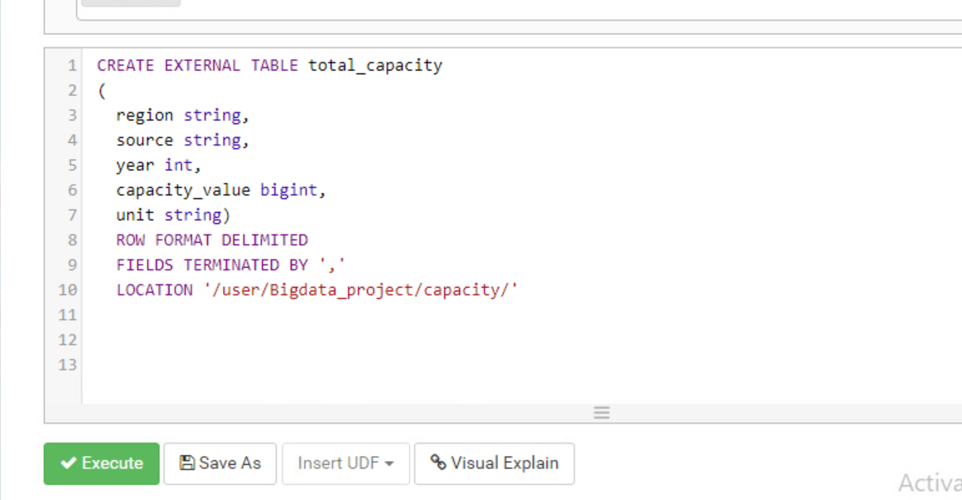

Cleaning

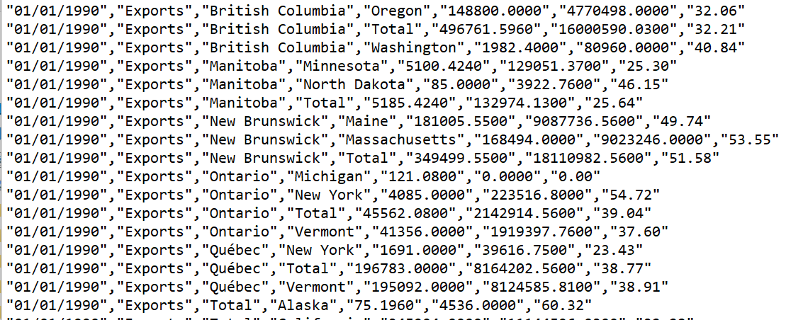

Query to display chart for Analysis 1

For Ontario:

And we have repeated this query for all other provinces

For bc:

For Quebec:

For New Brunswick:

For nunavat:

View creation:

=>Queries used for analysis 3

=>>Refined views:

=>

Ontario:

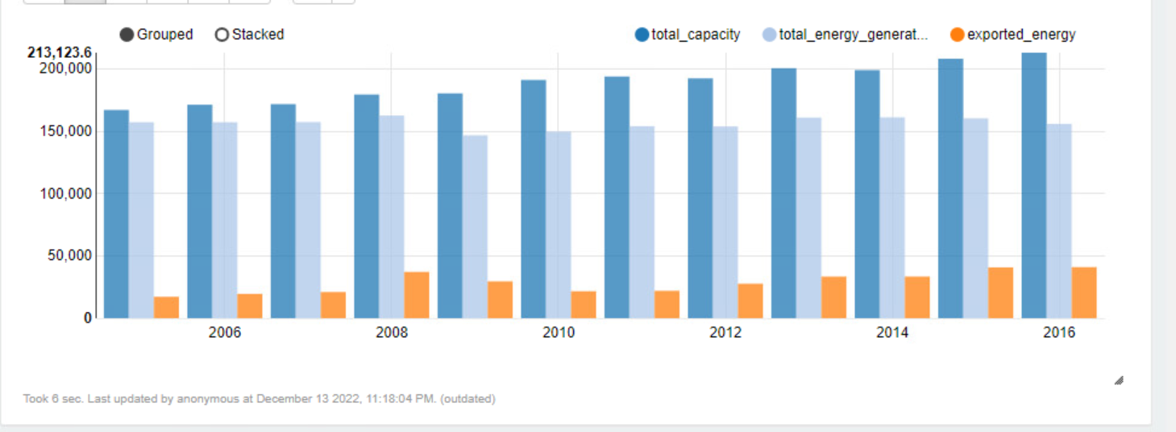

Qubec:

Bc:

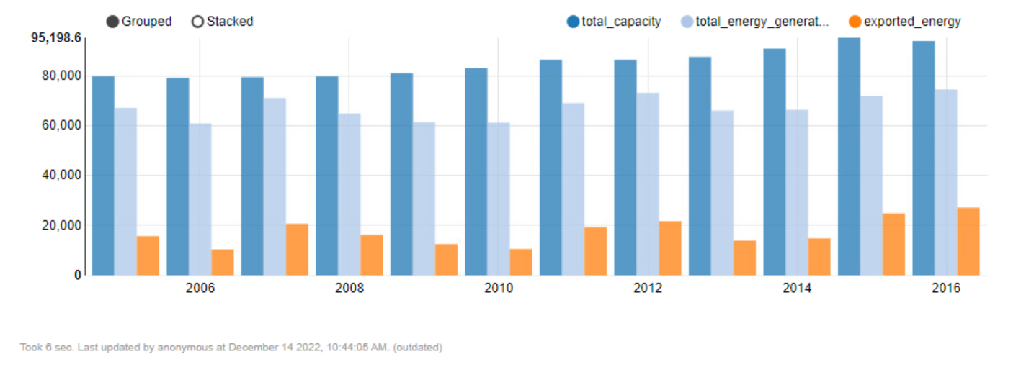

New Brunswick:

Nunavat:

No export

Analysis-3:

Import of all provinces

As you are seeing in above diagram, BC is the highest Importer of electricity in Canada now, we can view the capacity and generation of energy in BC.

From above diagram, we can measure that, BC can generate more electricity as they have enough plan capacity to generate and by doing that province can save that import cost.

To conclude that, provincial government of BC should focus more on generation and and work gradually to increase plan capacity.